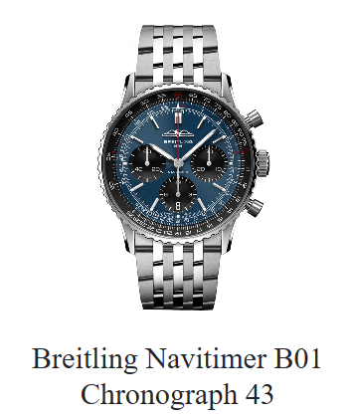

**Product Name:** Breitling Navitimer B01 Chronograph 43

**Description:**  
The Breitling Navitimer B01 Chronograph 43 is a distinguished pilot's watch that seamlessly blends classic design with modern innovation. Featuring the in-house Breitling 01 movement, this timepiece offers precision, a 70-hour power reserve, and a signature circular slide rule bezel for aviation calculations.

**Specifications:**

* **Movement:** Breitling 01 (Manufacture), self-winding mechanical
* **Power Reserve:** Approximately 70 hours
* **Chronograph:** 1/4th second, 30 minutes, 12 hours
* **Case Material:** Stainless steel
* **Case Diameter:** 43 mm
* **Case Thickness:** 13.69 mm
* **Water Resistance:** 3 bars (30 meters)
* **Crystal:** Cambered sapphire, glareproofed both sides
* **Bezel:** Bidirectional, slide rule
* **Strap:** Available in alligator leather or stainless steel bracelet
* **Dial Options:** Various, including blue, green, copper, and silver
* **Weight:** Approximately 98 g (without strap)

**Price:**

* **Retail Price:** $9,950 USD